1. **Start the application.**

This is how the program looks after being launched.

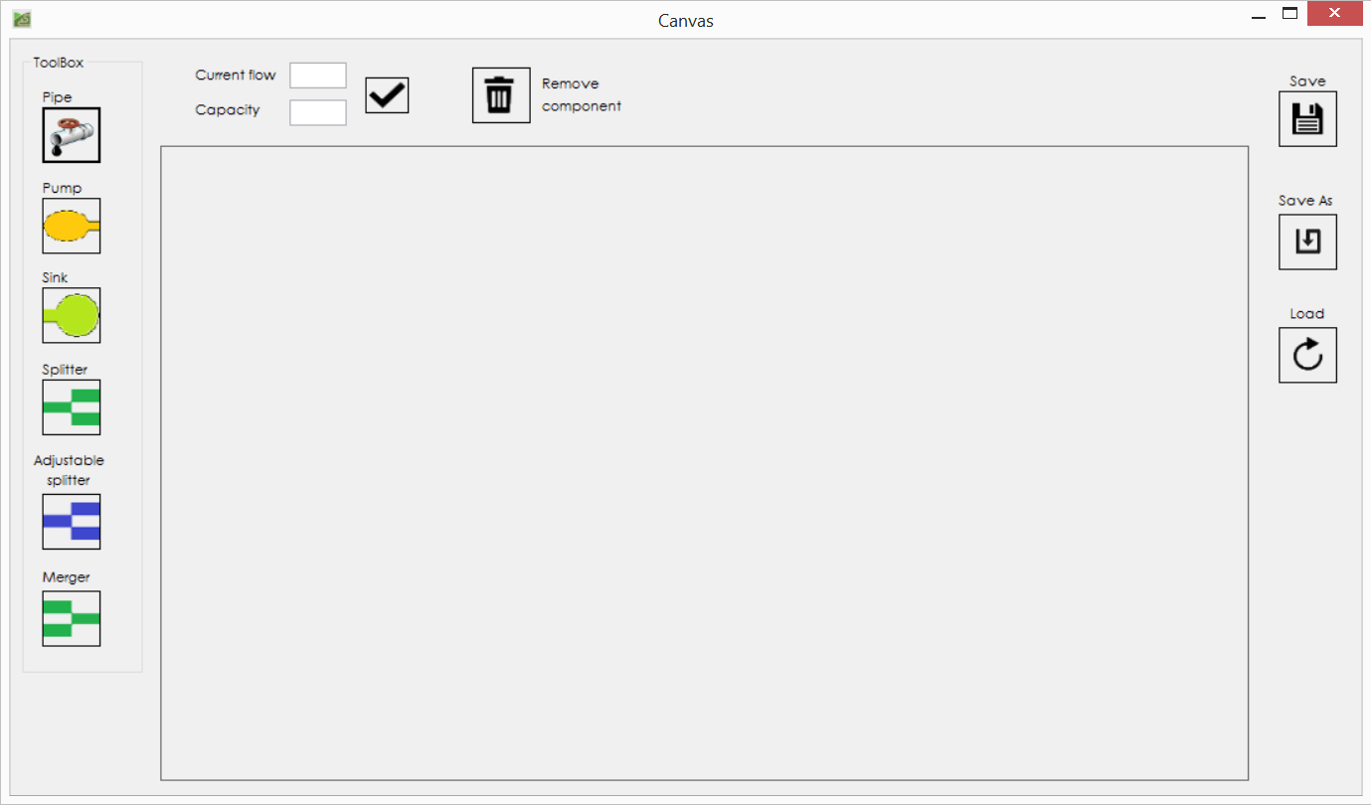

1. **Choose an item.**After selecting an item from toolbox you can measure where to place it by clicking on the drawing panel.

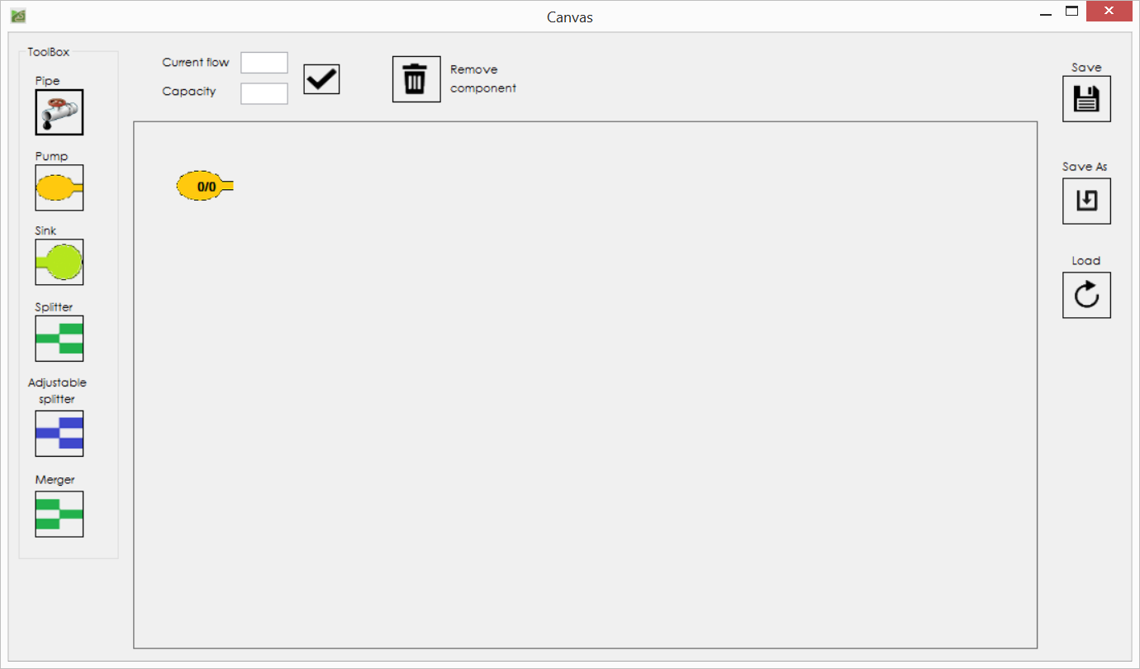

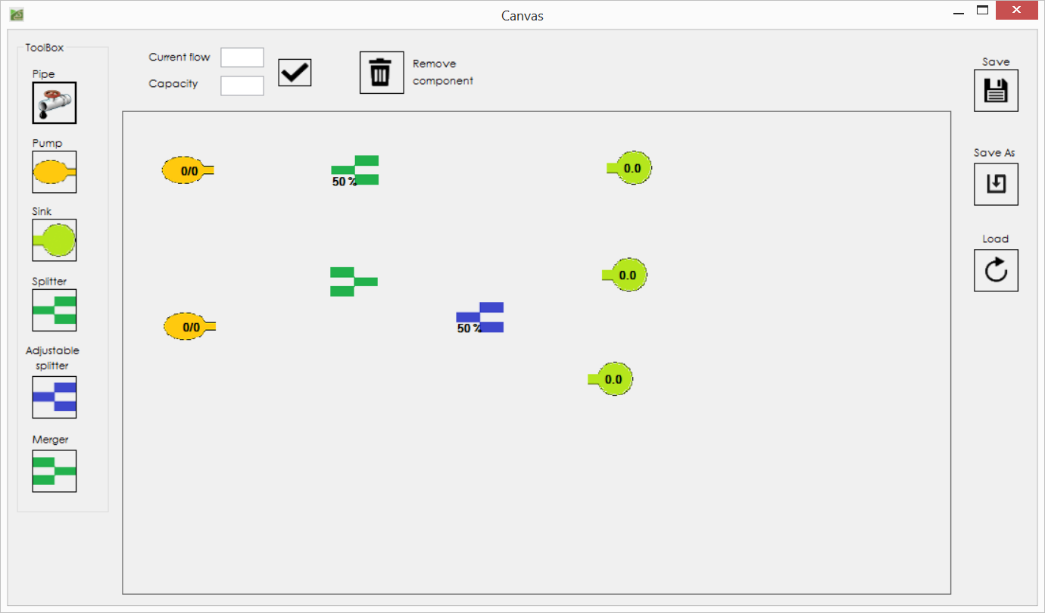

1. **Draw a line (make a connection).**

Once you draw the items that you want, you can connect them by selecting the line and clicking on those two elements that you want to connect. Or if you want the line to pass through specific points you can select them.

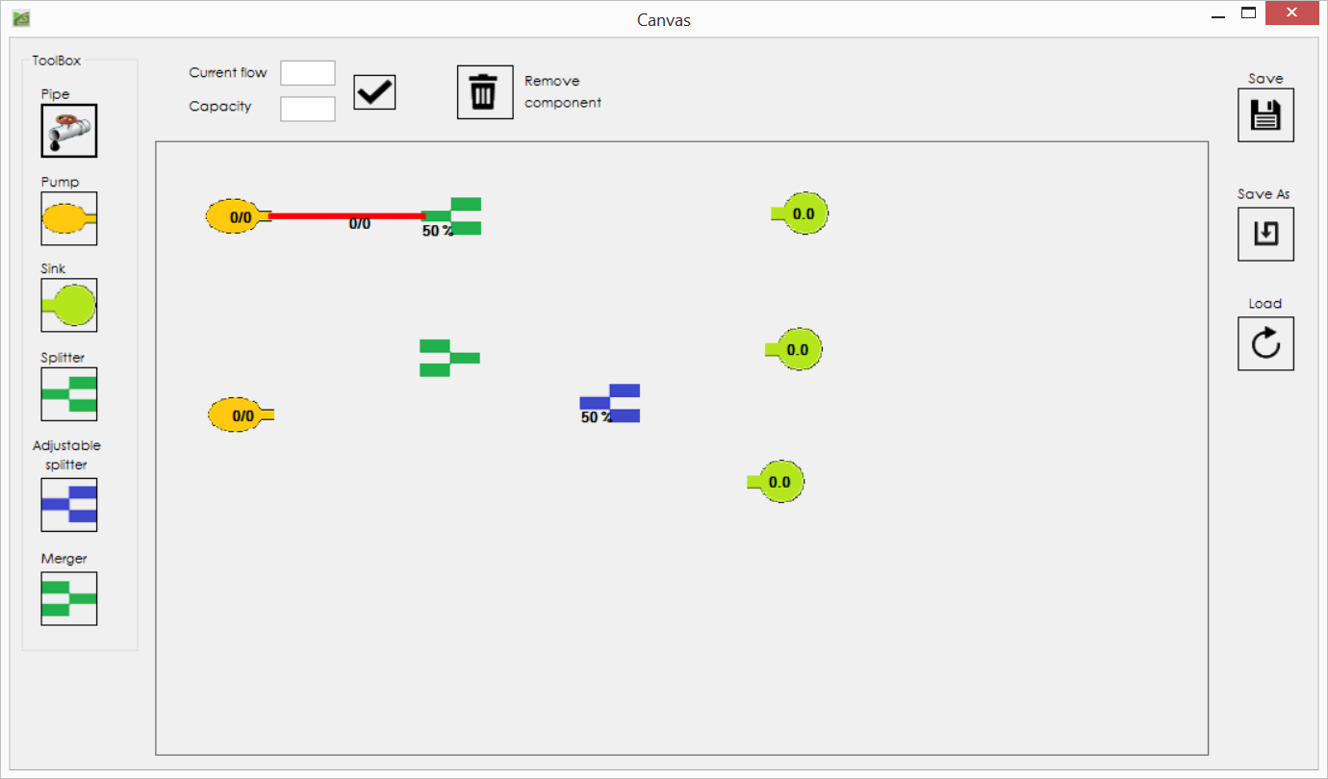

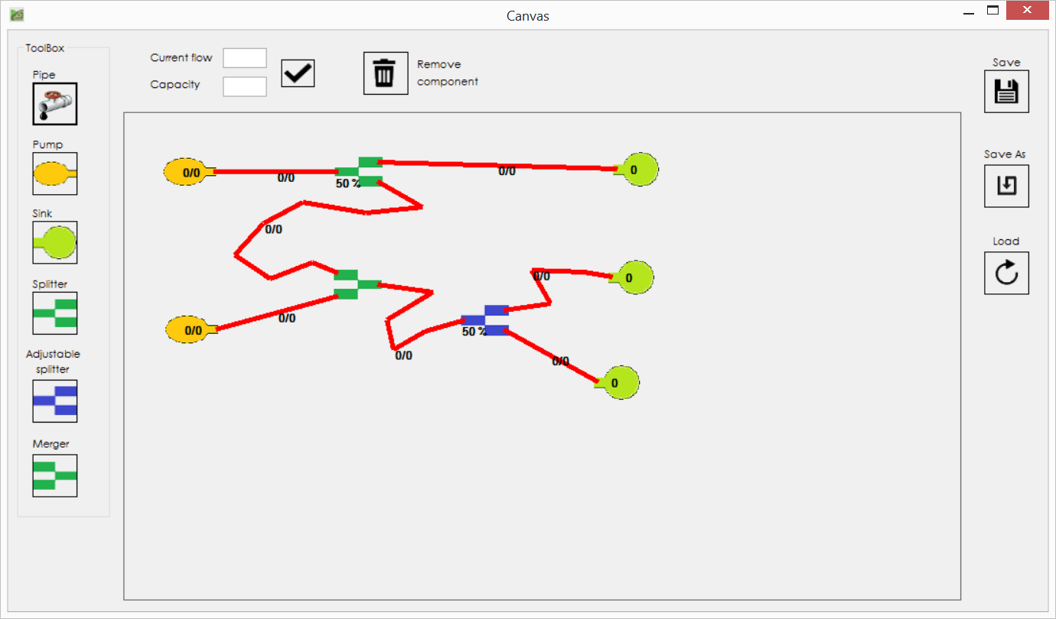

1. **Change the flow.**With double-click on the item that you want to change the flow you need to set the values that you would like and then to click on the tick button.

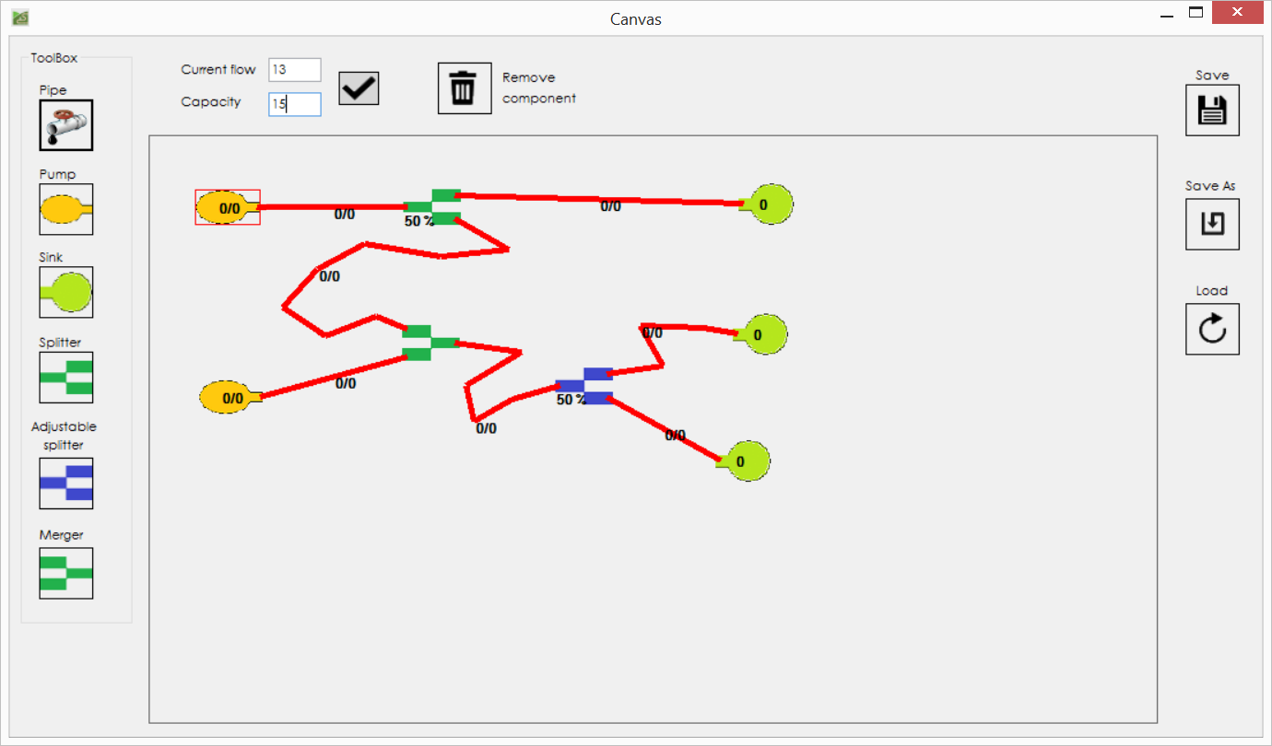

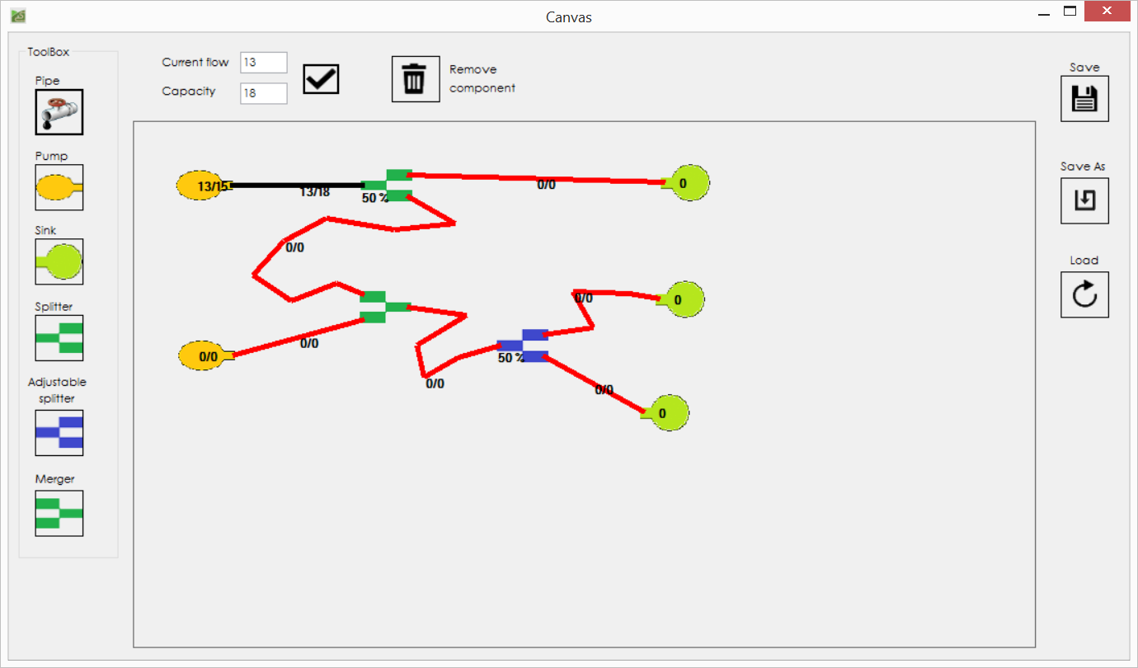

1. **Change the permeability of the adjustable splitter.**

Double-click on adjustable splitter you will get a bar from which you can choose what permeability to have your adjustable splitter.

